Create tables:

1.book:

CREATE TABLE PROJECT1_BOOK AS (SELECT ISBN10, ISBN13, TITLE FROM PROJECT1_BOOKS_LOAD);

Table PROJECT1_BOOK created.

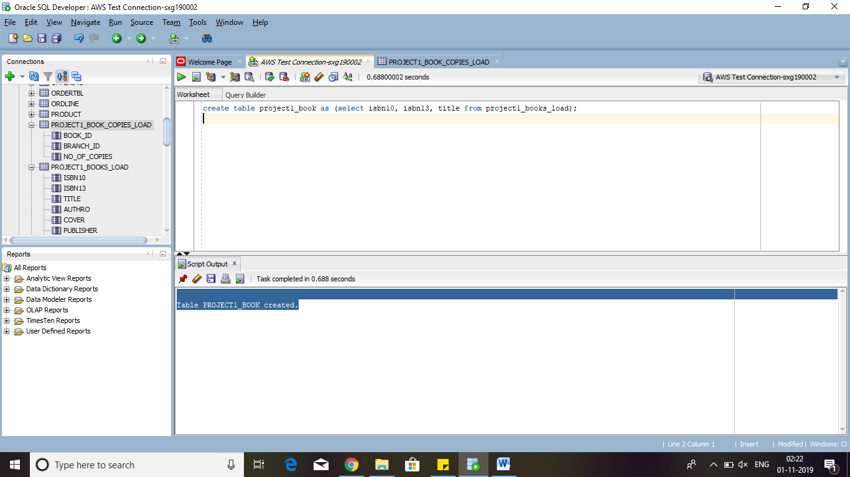

2.book_author

create table project1_book_authors as (select isbn10,isbn13 from project1_books_load);

Table PROJECT1_BOOK_AUTHORS created.

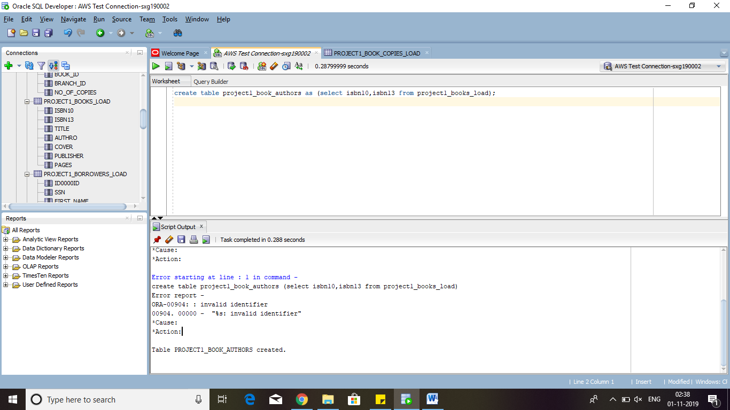

alter table project1_book_authors ADD author_id int;

Table PROJECT1_BOOK_AUTHORS altered.

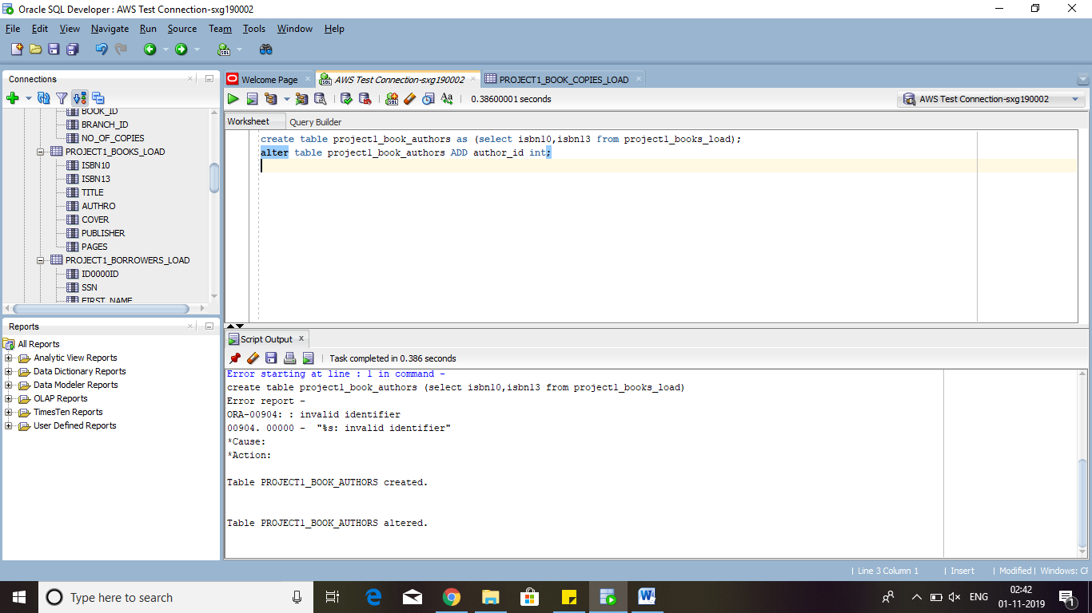

create sequence author_id increment by 1;

Sequence AUTHOR_ID created.

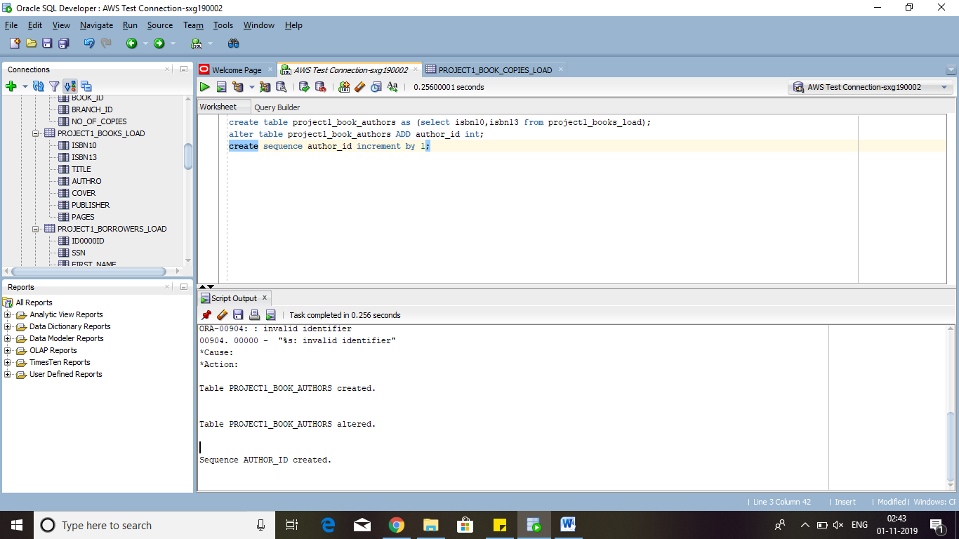

update project1_book_authors set author_id = author_id.nextval;

25,000 rows updated.

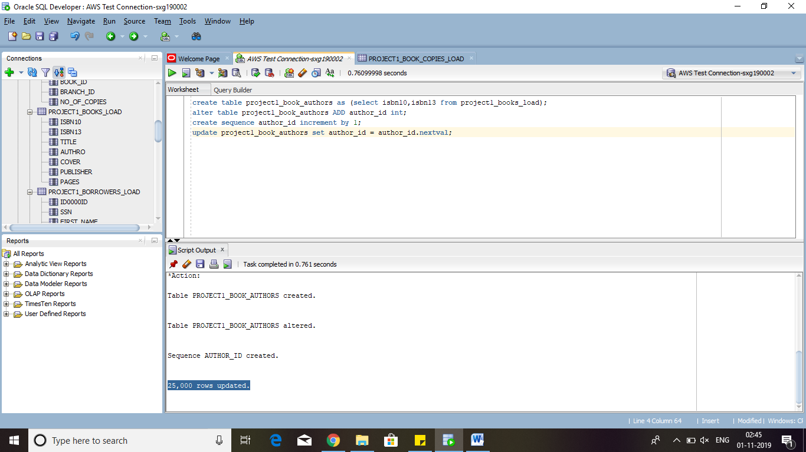

Table created: project1_book_authors

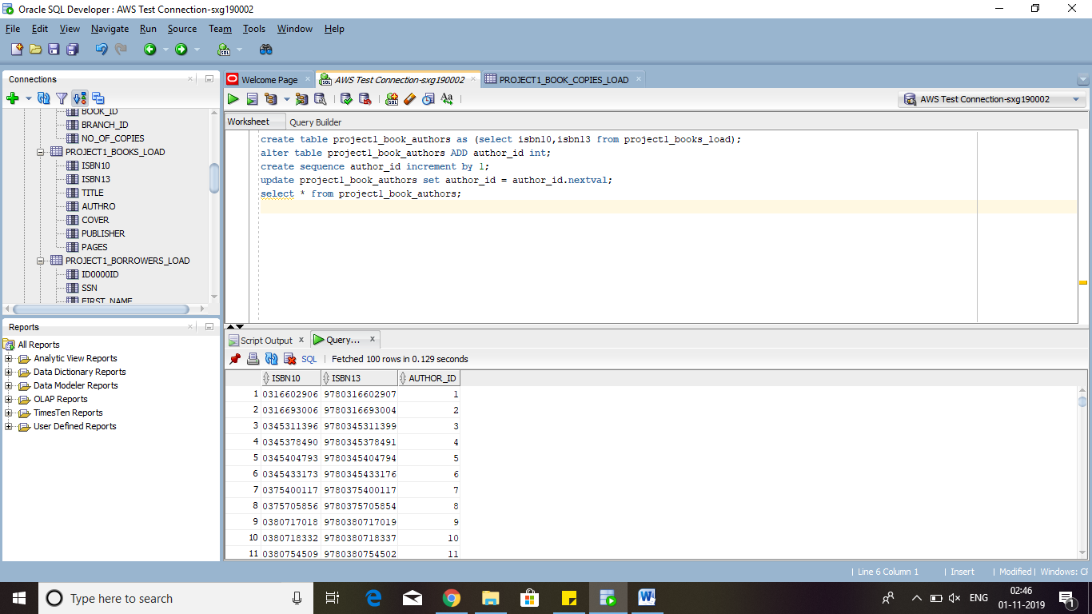

3. authors:

SELECT project1_book_authors.isbn10, project1_book_authors.isbn13,authro,author_id

FROM project1_book_authors

FULL OUTER JOIN project1_books_load

ON project1_book_authors.isbn10= project1_books_load.isbn10;

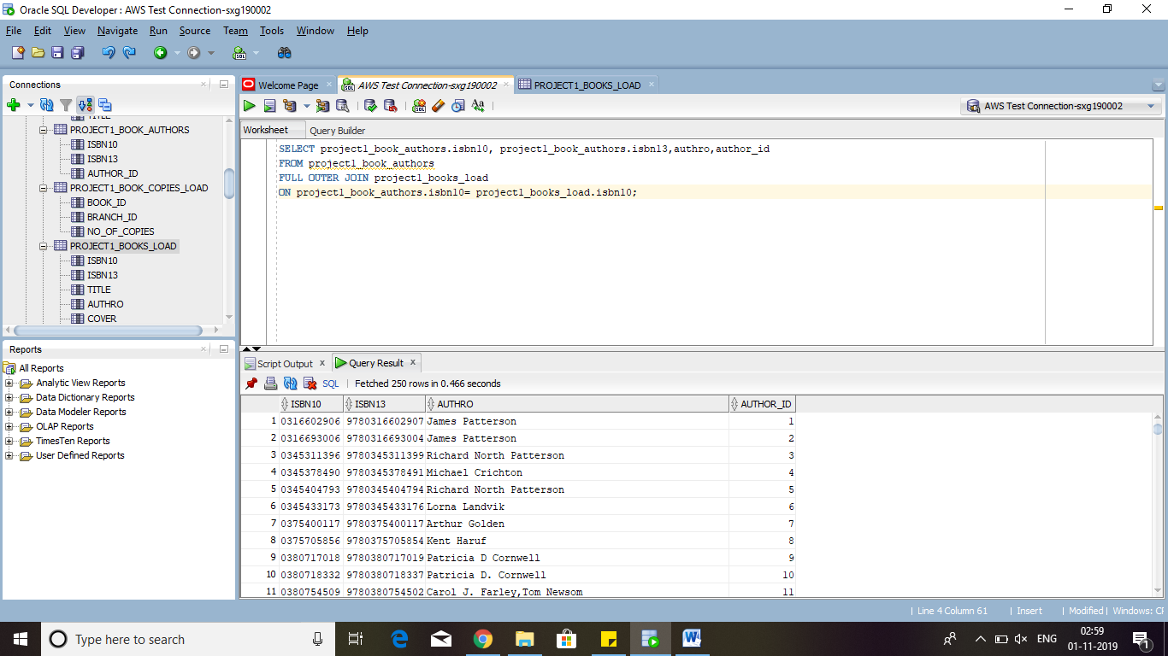

create table project1_authors as (SELECT authro,author_id

FROM project1_book_authors

FULL OUTER JOIN project1_books_load

ON project1_book_authors.isbn10= project1_books_load.isbn10);

Table PROJECT1_AUTHORS created.

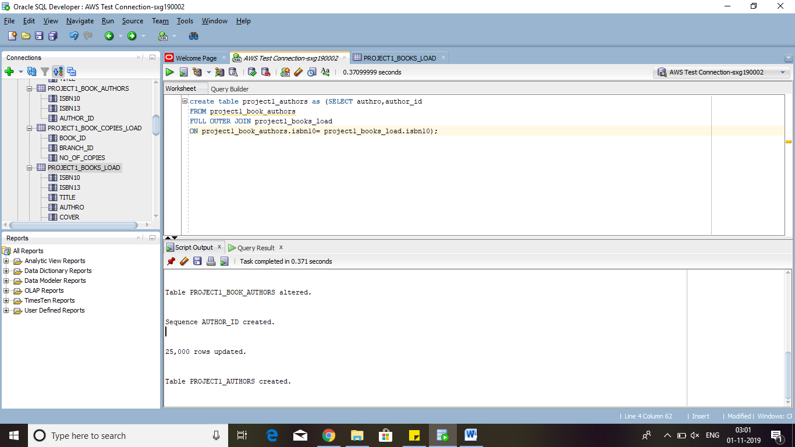

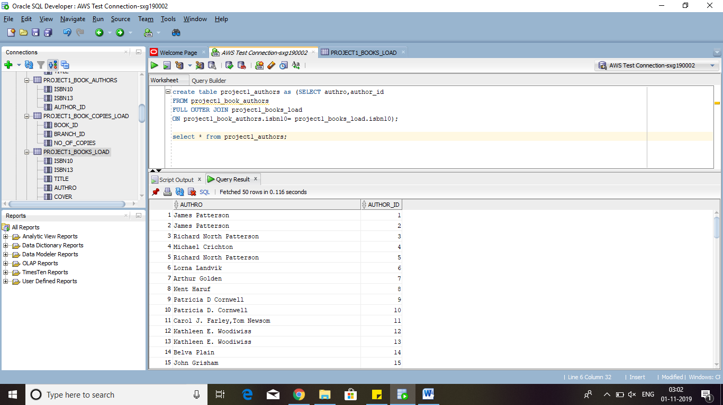

BORROWER

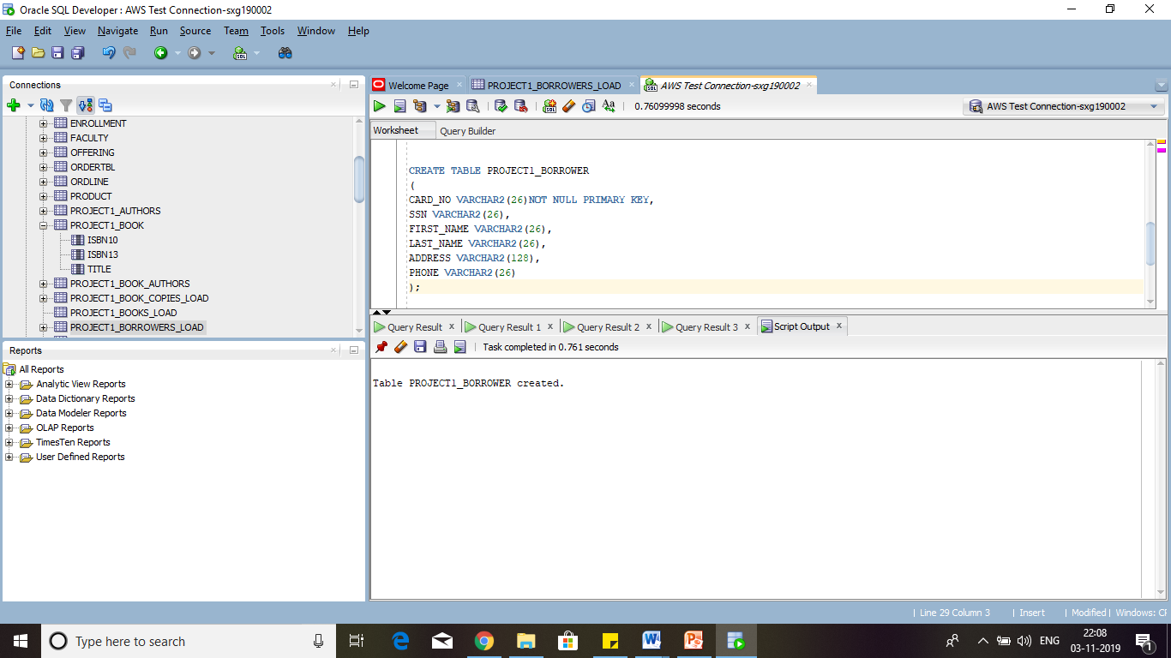

CREATE TABLE PROJECT1_BORROWER

(

CARD_NO VARCHAR2(26)NOT NULL PRIMARY KEY,

SSN VARCHAR2(26),

FIRST_NAME VARCHAR2(26),

LAST_NAME VARCHAR2(26),

ADDRESS VARCHAR2(128),

PHONE VARCHAR2(26)

);

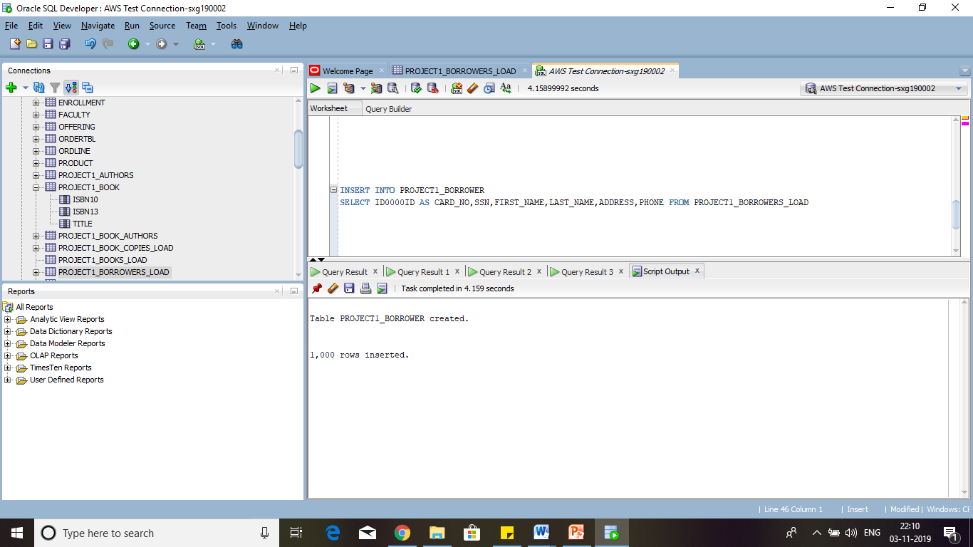

--INSERT INTO BORROWERS--

INSERT INTO PROJECT1_BORROWER

SELECT ID0000ID AS CARD_NO,SSN,FIRST_NAME,LAST_NAME,ADDRESS,PHONE FROM PROJECT1_BORROWERS_LOAD

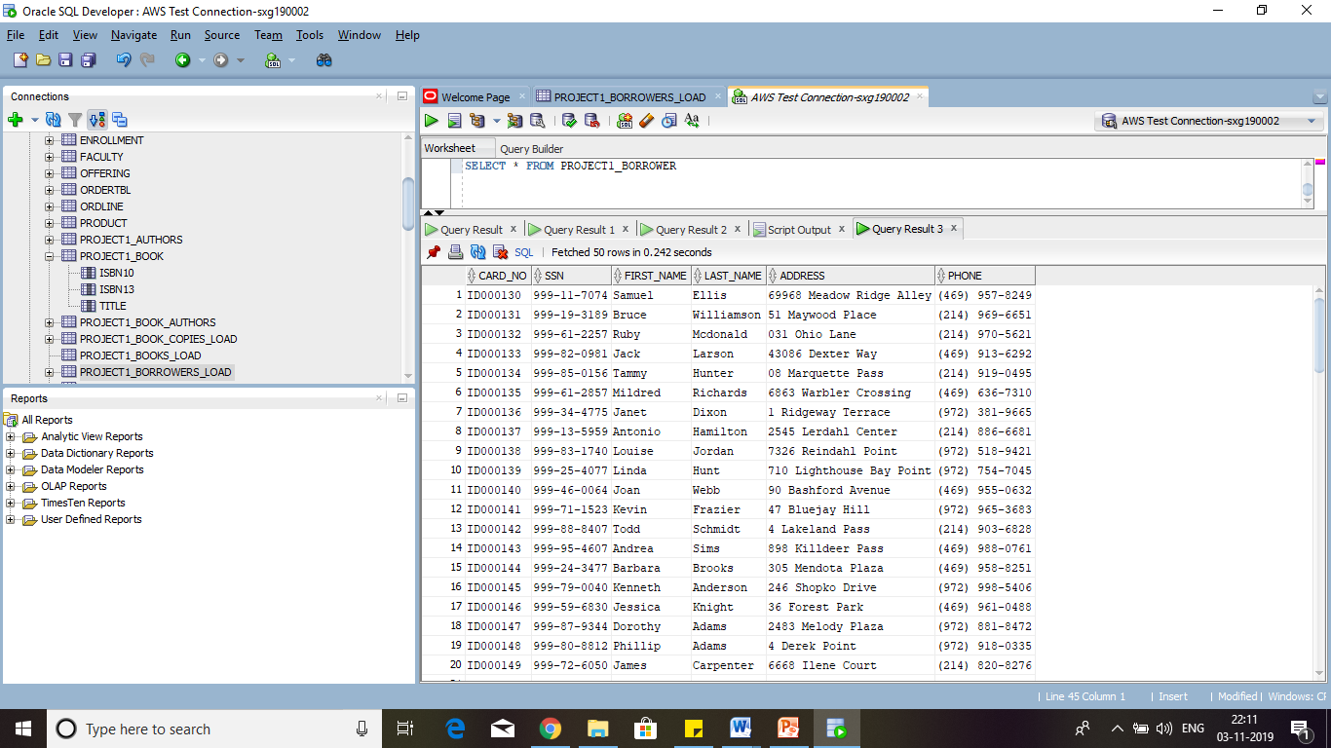

--PROJECT1_BORROWER--

SELECT * FROM PROJECT1_BORROWER

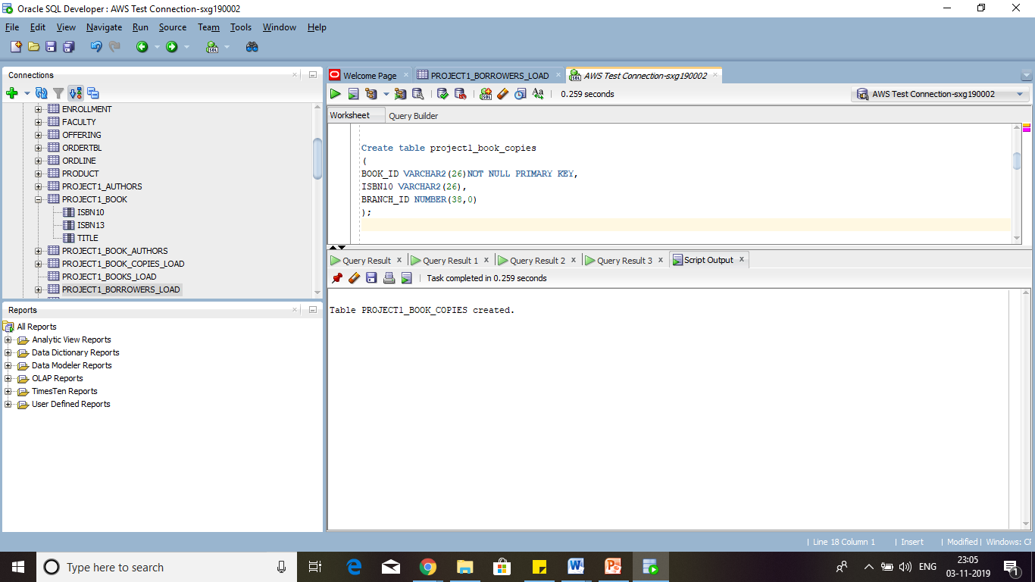

BOOK_COPIES

Create table project1_book_copies

(

BOOK_ID VARCHAR2(26)NOT NULL PRIMARY KEY,

ISBN10 VARCHAR2(26),

BRANCH_ID NUMBER(38,0)

);

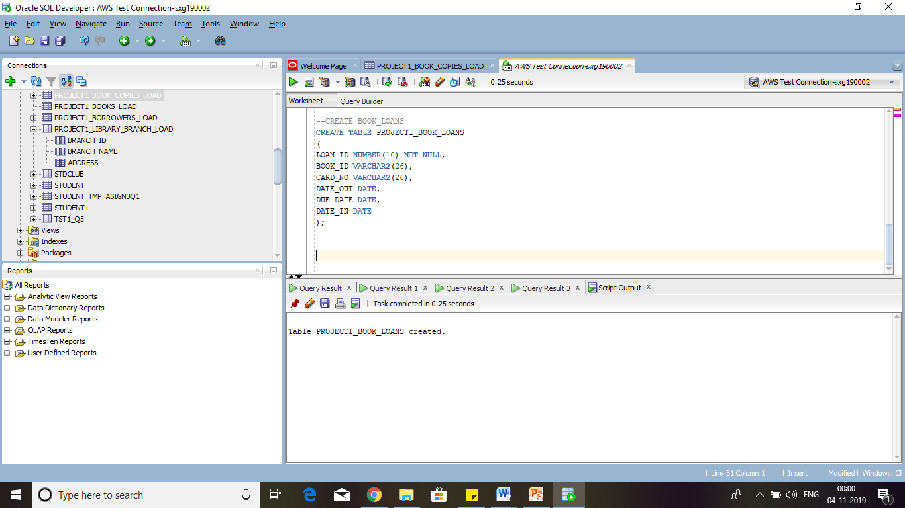

--CREATE BOOK_LOANS

CREATE TABLE PROJECT1_BOOK_LOANS

(

LOAN_ID NUMBER(10) NOT NULL,

BOOK_ID VARCHAR2(26),

CARD_NO VARCHAR2(26),

DATE_OUT DATE,

DUE_DATE DATE,

DATE_IN DATE

);

DECLARE

BOOK_ID NUMBER;

CARD_NO VARCHAR2(26);

DATE_OUT DATE;

DUE_DATE DATE;

DATE_IN DATE;

DATE_TEMP NUMBER;

BEGIN

for i in 1..750 loop

SELECT BOOK_ID INTO BOOK_ID FROM

(SELECT BOOK_ID FROM PROJECT1_BOOK_COPIES --WHERE NO_OF_COPIES <>0

ORDER BY DBMS_RANDOM.VALUE)

WHERE ROWNUM=1;

SELECT CARD_NO INTO CARD_NO FROM

(SELECT CARD_NO FROM PROJECT1_BORROWER

ORDER BY DBMS_RANDOM.VALUE)

WHERE ROWNUM=1;

select (to_date(TRUNC(DBMS_RANDOM.VALUE(2458485,2458849)),'J'))

INTO DATE_OUT

from dual;

due_date := date_out + 8;

date_TEMP := to_number(to_char(date_out,'j'));

select (to_date(trunc(dbms_random.value(date_TEMP,date_TEMP+15)),'J')) into date_in from dual;

insert into PROJECT1_BOOK_LOANS(LOAN_ID,CARD_NO,BOOK_ID,DATE_OUT,DUE_DATE,DATE_IN)

values (LOAN_ID.nextval,CARD_NO,BOOK_ID,DATE_OUT,DUE_DATE,DATE_IN);

END LOOP;

COMMIT;

END;

------------------------------------------------------------------------------------------

Create table project1_FINES

(

LOAN_ID NUMBER(38,0)NOT NULL,

FINE_AMT NUMBER(38,0),

PAID VARCHAR2(20)

);

INSERT INTO project1_FINES

SELECT

LOAN_ID,

DATE_IN - DUE_DATE,

'Yes'

FROM

PROJECT1_BOOK_LOANS

WHERE

DUE_DATE < DATE_IN

update PROJECT1_FINES set pAID = 'No' WHERE Loan_Id <= 550

select * from project1_FINES order by lOAN_Id

